Table Content
Table Content 1
Chp1 3
Chp2 (HTML) 4
Ordered list vs Unordered list vs Description list (Theory) 4
Ordered list vs Unordered list vs Description list (HTML Code) 4
Construct table (HTML Code) 6
Absolute path vs Relative Path 8
Input Controls for form fields 8
Chp 3 (CSS) 15
Inline CSS 15
Embedded CSS 15
External CSS 15
Color Names 15
RGB color value 16
HEX color value 16
Chp 4 (JS) 17
Inline JS 17
Embedded JS 17
External JS 17
Example of JS / JQuery events 17
Chp 5 (PHP) 18
General Data Types (3) 18
Scalar 18
Compound 18
Special 18
Loose Data Type 19
Types of Arrays (2) 20
Import Other File (4) 21
Sticky Form 21
Chp 6 (Database) 23
Advantages 23
PDO 23
Prepared Statement and Parameterized Query 23
Select Record 24
Database transaction 24
Database security practices (at least 3 point) 24
Code Part 26
Chp 7 (Security) 28
Input Validation 28
Input Sanitization 28
Output Encoding 29
Stateless Protocol 30
HTTP Session 30
HTTP Cookie 30
Authentication 31
Authorization 31
Password Hashing 32
Hashing Algorithm: 32
Enforce password strength or strong password: 33
Key Point: 32
Validating uploaded files 34
● File upload security practices (remember at least 3 point) 34

Chp1

Chp2 (HTML)

Ordered list vs Unordered list vs Description list (Theory)

Ordered list | - Used for item that follow some defined sequential order  - Such as items arranged alphabetically or numerically
Unordered list | - Used for lists in which the items have no sequential order
Description list | - Contain a list of terms and matching description

Ordered list vs Unordered list vs Description list (HTML Code)

 |  | Code | Output
Ordered list | Normal | 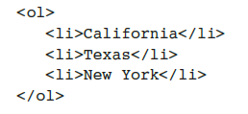 | 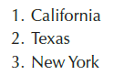
Ordered list | Reversed start | 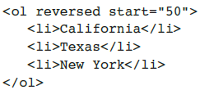 | 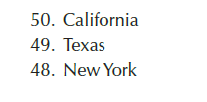
Unordered list | Normal | 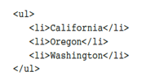 | 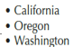
Description list |  | 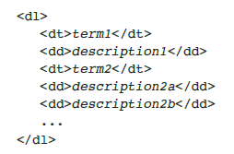 | 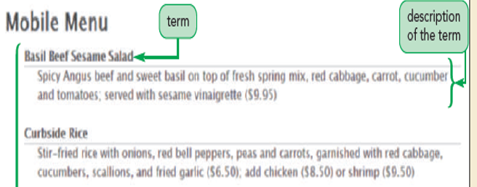

Construct table (HTML Code)

Element | Attribute
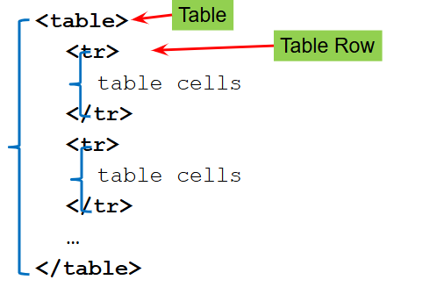 | 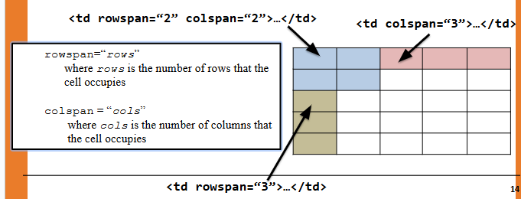
Example:  <table>  <tr>  <td>Takoyaki</td>  <td>Octopus</td>  <td>柴鱼</td>  </tr>  <tr>  <td>Tamago</td>  <td>Egg</td>  <td>Pan</td>  </tr>  </table>  Output: | Example:  <table>  <tr>  <td>Takoyaki</td>  <td>Octopus</td>  <td>柴鱼</td>  </tr>  <tr>  <td rowspan = "2">Tamago</td>  <td colspan = "2">Egg</td>  </tr>  <tr>  <td>Pan</td>  </tr>  </table>  Output:
  Takoyaki | Octopus | 柴鱼
  Tamago | Egg | Pan
  Takoyaki | Octopus | 柴鱼
  Tamago | Egg
  Tamago | Pan

Absolute path vs Relative Path

Absolute path | Relative Path
- Specifies a file’s precise location within a computer’s entire folder structure.  - Start with slash.  - Suitable when link are common reusable in other page.  - Example:  - 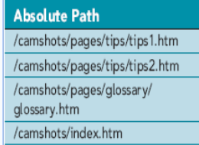 | - Specifies a file’s location in relation to the location of the current document  - Not begin with slash  - Suitable when link not be reused in other page  - Example  - ../felix.php  - /takoyaki.php

Input Controls for form fields

Input Controls
textbox | For single line text input. Normally use in input name and similar meaning fields  Output:  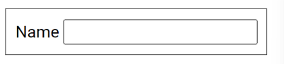
textarea | For multiline text input  Output:  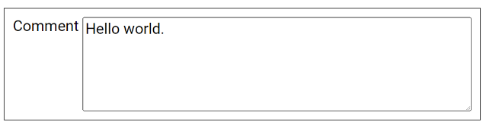
Checkbox | To indicate TRUE or FALSE status  Output:  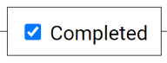
Radio button list | Select single value from predefined list.  Output:  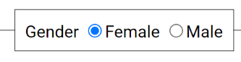
Single-selection list | Select single value from predefined list  Output:  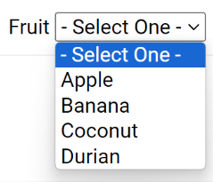
Checkbox list | To select multiple value from a predefined list  Output:  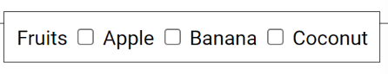
Multi-selection list | Select multiple value from predefined list.  Output:  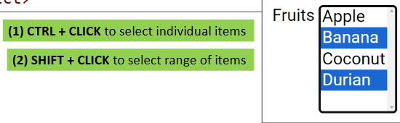
Password field | Use for input password and input value obscured  Output:  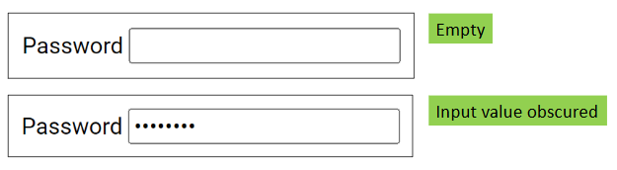
Slider | For numeric input, user can select number within a range.  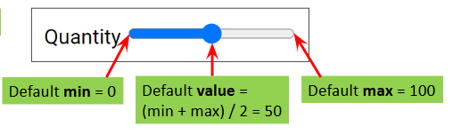
Spinner | For numeric input, accept only digit, decimal dot(.) , -, + and exponent (e).  Output:  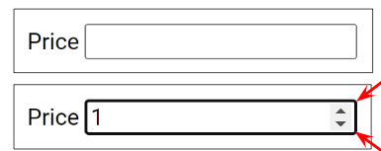
Date picker | Select date and time from calendar control  Output:  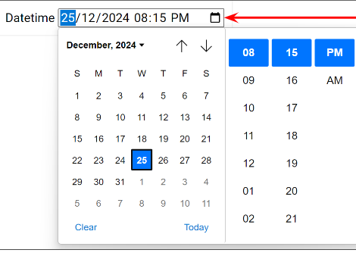
Time picker | Select time from calendar control  Output:  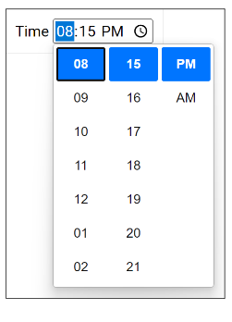
Color picker | To select color from color picker  Output:  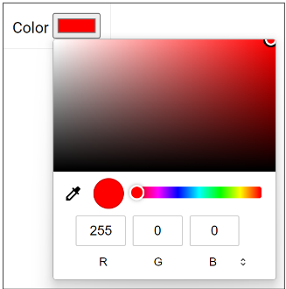
File picker | Select one or multiple files from file picker  Output:  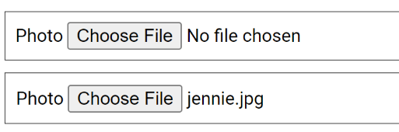
Search | Mainly for searching purpose.  Output:  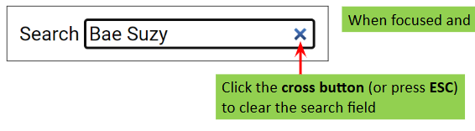

Chp 3 (CSS)
Inline CSS | - CSS rules are added to a single element via the style attribute.  - Affecting only this particular element.  - No reusability
Embedded CSS | - Css rules are added to a single page via the <style> element.  - Affecting all element in this particular page.  - Page-level reusability.
External CSS | - CSS rule are added to an external CSS File  - Affecting all elements in all pages that linked with the CSS file.  - Site-level reusability

Color Names | Modern browsers support 140 standard color names.  Color names are case-insensitive | ✅:  - Easy to use.  - No understanding of light color and concepts is required
Color Names |  | ❌:  - Only support 140 standard color names  - Cannot specify a color precisely  - Hard to remember all standard color names
RGB color value | Specify the intensity of the 3 primary colors as integers between 0-255. | ✅:  - Support 256^3 unique colors  - Specify a color precisely  - Function is short (HEX)  ❌:  - Require some understanding of light and color concepts  - Function is long (RGB)
HEX color value | Express RGB values by using 3 pairs of 2 digit hexadecimal numbers between 00-ff

Chp 4 (JS)
Inline JS | Embedded JS | External JS
- Write JavaScript within the one event attribute of an individual element.  - Usually for event handlings.  - No reusability | - Write JavaScript within the <script> tag of the web page.  - Can have multiple <script> tags in <head> and <body> tags.  - Page-level reusability | - Write JavaScript within external JavaScript files.  - Then import into web pages using the <script src=”...”> tag.  - Site-level reusability

Example of JS / JQuery events
- Click to toggle visibility of an image
- Double-click to remove a list item
- Change background color when mouse enter
- Moving the mouse over an element (e.g. image)
- Selecting a radio button or checkbox
- Clicking on an element (e.g. button)

Chp 5 (PHP)

General Data Types (3)
Scalar | Compound | Special
- Data that contains a single value | - Data that contains more than one value | - Not scalar and compound but they have specific meaning
Data Types: | Data Type: | Data Type:
  Integer | A whole number
  Float | A floating-point number
  String | A series of character
  Boolean | Represent either true or false
  Array | An list of values referenced by name or index
  Object | A type that contains properties and methods
  Resource | Contains reference to an external resource, such as file or database
  Null | Contain null as a value

Loose Data Type
Definition
- No deed to specific data type when declaring PHP variable.
- PHP converts a variable's data type automatically depending on the value assigned.
- Example
  - In C, C++ or Java declaring variables like “int value = 3;” , which is strongly-typed.
  - In PHP, declare variables like “$value = 3; “.
- Simple PHP codes to demonstrate loose data
  - $a = 123; // $a is integer
$a = ‘A’; // $a is string now
✅:  - Flexibility  - Flexible in declaring variables  - Easy to use  - Same variable can easily be used in different situations.  - Reduce worry  - Programmers do not have to worry about the type of variable when declaring them. | ❌:  - Hard to identify  - Hard to Identify if an error happens when a floating-point number is passed to code that expects an integer.

Types of Arrays (2)
Indexed Array | Associative Array
- Each element is referenced by a numeric index  - First index or key starts with 0  - Second index or key is 1 and so on  Example Code: | - Also called a hash or map  - Each element is referenced by a string key  Example Code:
  // Declaring array
  $a = [
  ‘Apple’,
  ‘Banana’,
  ‘Coconut’
  ];
  // Access and Change element
  echo $a[0]; // output: Apple
  $a[0] = ‘Orange’;
  echo $a[0]; // output: Orange
  // Declaring array
  $a = [
  ‘APP’ => ‘Apple’,
  ‘BNN’ => ‘Banana’,
  ‘CCN’ => ‘Coconut’
  ];
  // Access and Change element
  echo $a[‘APP’]; // output: Apple
  $a[‘APP’] = ‘Orange’;
  echo $a[‘APP’]; // output: Orange

Import Other File (4)
include | - Import the targeted file  - Produce warning and the script continue running if the targeted file is not found | ✅:  - Reusable base library function  - Reusable layouts for consistent page design  - Reduce the complexity of individual pages  - Group relevant components together in separated file  - Easy to maintain. Update at one place, affect all pages.
require | - Imported the targeted file  - Produce error and the script stop running if the targeted file is not found
include_once | - Same as include / require  - But the targeted file will only be imported once.  - Subsequence attempts will be skipped.
require_once

Sticky Form
- Retains inputs even after form submission
- Giving users a chance to review and correct input errors, then resubmit the form one corrections have been made.

Chp 6 (Database)

Advantages
PDO | Prepared Statement and Parameterized Query
- Object-Oriented Approach  - Promotes better organization and structure in code.  - Database Compatibility  - Works with various databases (e.g., MySQL, SQLite, Oracle) if PDO drivers are available.  - Data Access Abstraction  - Allows the same PDO functions for queries and data fetching, regardless of the database.  - Easy Database Switching  - Changing databases typically requires minimal adjustments to SQL statements. | - Automatic Escaping  - Prepared statements automatically escape special characters in SQL parameters.  - Prevention of SQL Injection  - This feature helps protect against common security vulnerabilities like SQL injection.

Select Record
fetchAll() | Return multiple records as an array of objects
fetch() | Return one record as an object
fetchColumn() | Return one scalar value

Database transaction
- Use to group a sequence of related database operations together as a single units
- Ensure that all database operations must succeed for changes to be saved.
- If any operation fails, no changes will be made.

Database security practices (at least 3 point)
- Use Prepared Statements
  - Always use prepared statements and parameterized queries instead of mixing SQL with variables.
- Input Validation
  - Validate inputs and encode outputs to handle special characters (e.g., use the quote() function).
- Stored Procedures
  - Use stored procedures to manage data access and prevent direct access to base tables.
- Minimal Privileges
  - Access databases with the lowest necessary privileges (e.g., no permissions to CREATE or DROP tables).
- Role-Based Accounts
  - Create separate database accounts for different user roles and grant only the needed permissions.
- Change Default Credentials
  - Change the default database admin username and password (e.g., don’t use 'root' and an empty password).
- Change Default Port
  - Change the default port number for the database server, and if possible, host it on a different machine.
- Remove Unnecessary Content
  - Delete unnecessary default vendor content, like sample schemas or tables.
- Turn Off Unused Features
  - Disable unnecessary database functionality, services, and packages.
- Disable Database Clients
  - Turn off or disable database clients (e.g., PHPMyAdmin) when not in use.
- Use Strong Passwords
  - Utilize strong passwords and multi-factor authentication if supported.
- Secure Database Settings
  - Do not hardcode database settings in code; store them in a separate encrypted file.

Code Part
Function involves:  - query()  - prepare()  - execute()  - fetchAll()  - fetch()  - fetchColumn() | Code Example (Provided from lecturer):  - Select all fruits records. Store the result in array $arr. Use query() and fetchAll()  - SELECT a fruit record based on $id. Store the result in variable $f. Use prepare(), execute() and fetch() functions in your solution.  - SELECT the COUNT of all fruit records. Store the result in variable $count. Use query() and fetchColumn() functions in your solution.  - INSERT a fruit record using inputs stored in $id, $name and $price. Use prepare() and execute() functions in your solution.
  $arr = $_db->query(‘SELECT * FROM fruit’)->fetchAll();
  $stm = $_db->prepare(‘SELECT * FROM fruit WHERE id = ?’);
  $stm->execute([$id]);
  $f = $stm->fetch();
  $count = $_db->query(‘SELECT COUNT(*) FROM fruit’)->fetchColumn();
  $stm = $_db->prepare(‘INSERT INTO fruit (id, name, price) VALUES (?, ?, ?)’);
  $stm->execute([$id, $name, $price]);

Chp 7 (Security)

Input Validation | Input Sanitization
- Check if input meets certain criteria  - such as length, format.  - Does not alter the input  - Example  - check if an input meets the standard email format.  Suggest input validation for given data (Example):  Given ERD and sample data  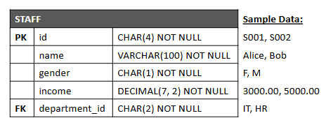  Suggest  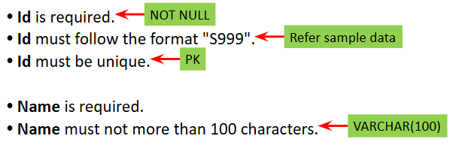  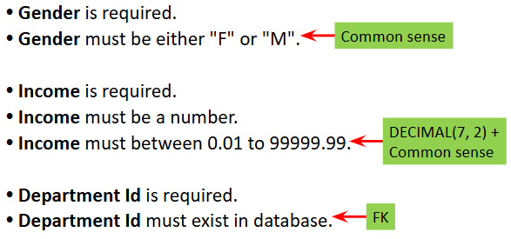 | - Alter input by removing undesired characters  - such as HTML tags  - Does not validate the input.  - Example  - remove illegal characters from an email address.

Output Encoding
- Convert special characters into HTML entities when displaying content from untrusted sources (like user inputs or database records).
- This ensures that outputs aren't rendered as HTML tags or attributes, preventing execution by the browser.
- This is a security measure to protect against cross-site scripting (XSS) attacks, which allow attackers to inject malicious code into web pages.

Stateless Protocol
- HTTP is a stateless protocol.
- Each request from a client to the server is treated as new and independent, even it comes from the same client.
- The server doesn't remember any information between requests.

 | HTTP Session | HTTP Cookie
Suitable for data | security-critical and essential | not security-critical and essential
Duration time of store | Short period.  (By default, HTTP sessions last until the browser is closed.) | Long period.  (If the HTTP cookie is not deleted by the user.)
Storage | Use server storage.  (Too many large concurrent sessions can degrade server performance.) | Store at client.  (Hence does not add additional load to server storage)
Size limit | Large.  (Limited by PHP memory limit which default is 128 MB but can be configured) | Small.  (HTTP cookie is limited to 4KB per domain)
Page request size | Ignorable  (Only a small session id is sent along with each page request.) | Increase  (Cookie data is sent along with each page request.)
Usage Example | - Login session  - Shopping cart  - Payment status  - Inputs for multi-page form | - User preference  - Search and input history  - Last visit date and time  - Page visit count

Authentication | Authorization
- The process of verifying if a user is truly who they claim to be.  - Example  - Ask the user to provide a pair of email and password in the login page. Authenticate the user if the email and password are matched based on records in the database. | - The process of granting or denying a user access to protected pages, functions, resources or database records.  - Example  - Associate each user with a role. Authorize the user for accessing protected resources based on his role. E.g. if he is "Admin", he can add, update and delete records, otherwise deny him from doing so.

Password Hashing
- A security technique that protects passwords by converting them into a fixed-length string using a cryptographic algorithm
- The resulting hash is hard to reverse and looks nothing like the original password.
Hashing Algorithm:  - Basic (less secure):  - MD5, SHA1  - Advanced (more secure):  - SHA256, BCRYPT, ARGON2  Enforce password strength or strong password:  - Password length  - Ensure the password has a minimum length  - Eg. minimum 8-12 character  - Password Complexity  - Require a mix of uppercase letters, lowercase letters, digits and symbols. | Key Point:  - One-Way Process  - Easy to create a hash from a password, but nearly impossible to reverse it back to the password.  - Same Input, Same Hash  - The same password input will always produce the same hash, allowing systems to compare stored hashes with new passwords for verification.  - Salt  - A random value called a "salt" is added to the password before hashing.  - This ensures that even if two users have the same password, their hashes are different, adding extra protection against attacks like rainbow table attacks.  - Storing Password  - In secure systems, only the password hash (and salt) is stored, not the plain password.  - When a user logs in, their password is hashed and compared to the stored hash.  - Protects Against Breaches  - If a database is breached, attackers would still need significant effort to crack hashed passwords, especially with strong algorithms and salting in place.

Validating uploaded files
- Input validation
  - Validate a file is selected and uploaded (i.e. required).
  - Validate the file extension (e.g. ".jpg" or ".png" for photos).
  - Validate the file type (e.g. "image/jpeg" or "image/png").
  - Validate the file size (e.g. not more than 1MB).

File upload security practices (remember at least 3 point)
  - Validate properly
    - Properly validate the uploaded file, including the file extension, file type and file size.
  - Whitelist
    - Whitelist all the acceptable file extensions and file types. And reject all others.
  - Reject executable file
    - Expect if really necessary, reject all executable file such as EXE files, PHP files and other scripting files.
  - Set file size
    - Set a reasonable maximum acceptable file size. This prevents the server storage from being unnecessarily occupied.
  - If possible, save the uploaded file using a system-generated unique file name, rather than the original file name.
  - Crop and resize uploaded images to reduce file size. Convert all uploaded images to a consistent image type if possible.
  - Save uploaded files into a separated folder containing no scripting files. Then make this entire folder non-executable.

